Thomson, John A (Jack)
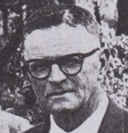
One of the original students at the Ludlow Apprentice School. Started as forest apprentice in March 1917, with the W.A. Forests Dept. In 1919 involved in timber assessment surveys near Manjimup, Margaret River, Karridale, Pemberton. Worked in Forests Department in 1920s-60s. In 1957/58 seconded to the Tree Society as Secretary-Organiser. Retired in 1962/63. Returned from retirement in 1963/64 to do tree establishment project in the north-west of the State. Contracted to do a survey of Boronia areas, for the Department, in 1969/70. Active in the conservation movement in his latter years. Died 7.8.1993.

